EE9-FPN1-01 SMART GRID TECHNOLOGIES

Solution Question 1

- Total load is 420 + 280 = 700 MW. The ED solution: Gen A produces 650 MW and Gen C produces 50 MW. Total cost is (650*25 + 50*60) = £19250/h [2]
- The flows can be calculated using superposition or dc load-flow.
First is to consider only load at bus 3. Second is to consider only load and generator at bus 4 and sum up the flows from these two conditions.
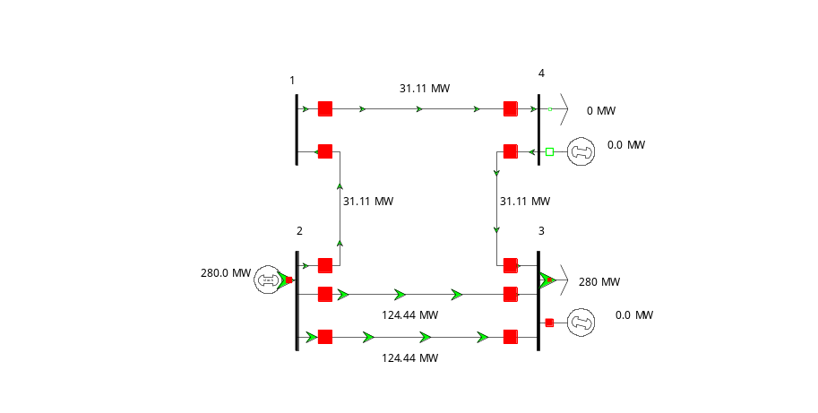
+
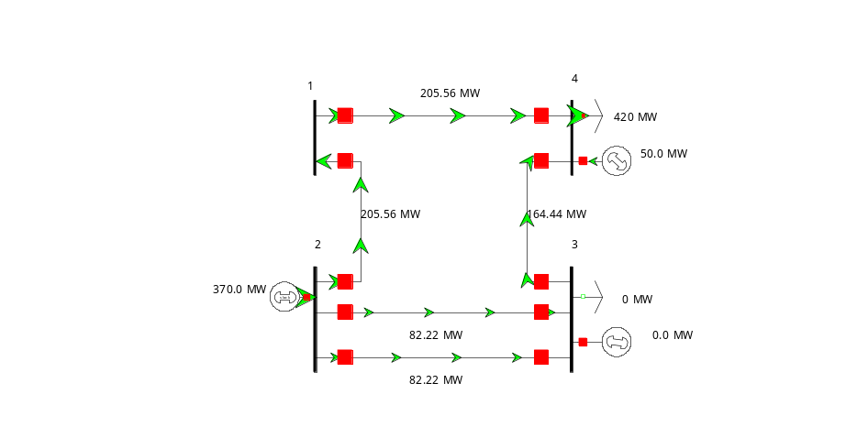
=
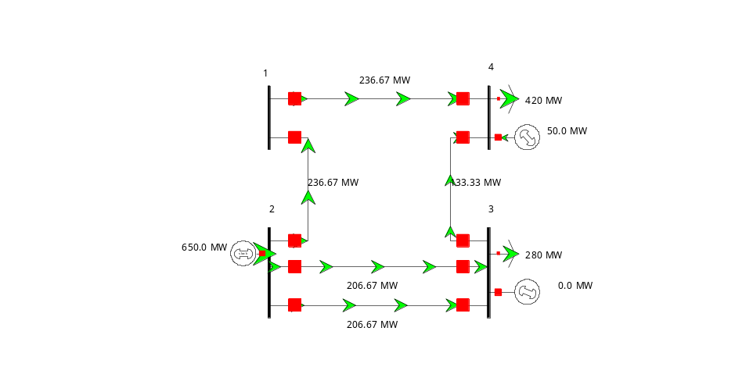
[3]
- The same approach (i.e. superposition/dc load-flow) can be used to carry out contingency analysis.
Line 1-2 or line 1-4 out of service:
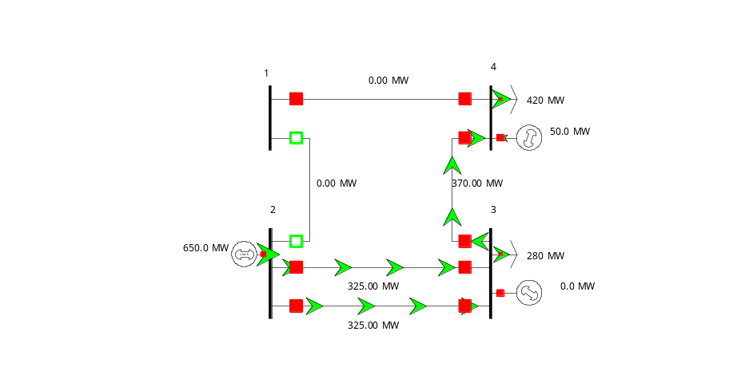
One of line 2-3 out of service: (in this condition, the other line 2-3 is overloaded by 22 MW)
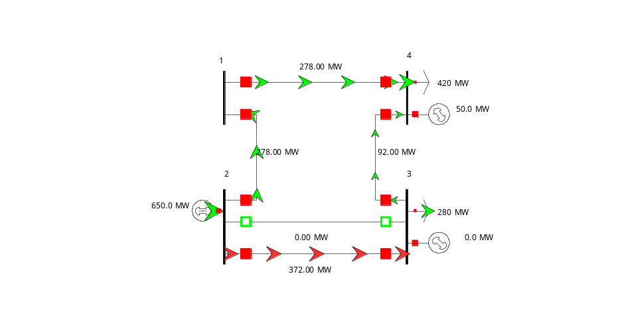
Line 3-4 out of service
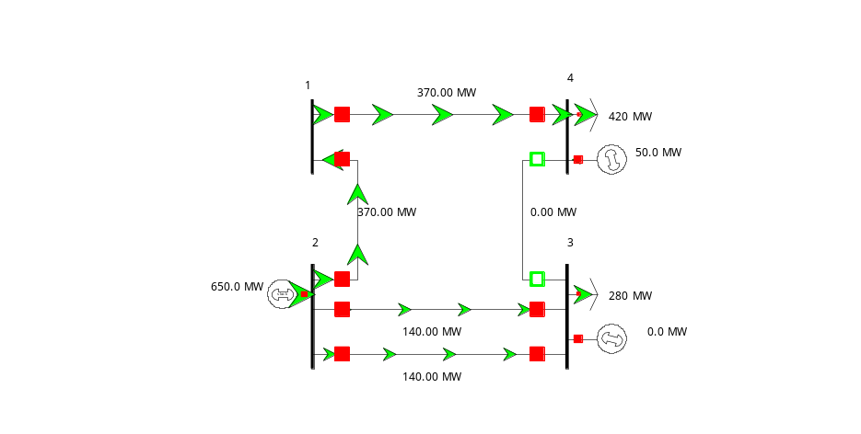
The critical contingency is an unplanned outage at line 2-3. [4]
- In order to operate securely in preventive mode, generator C has to increase its production. First is to evaluate the sensitivity of Gen C output to flows at 2-3.
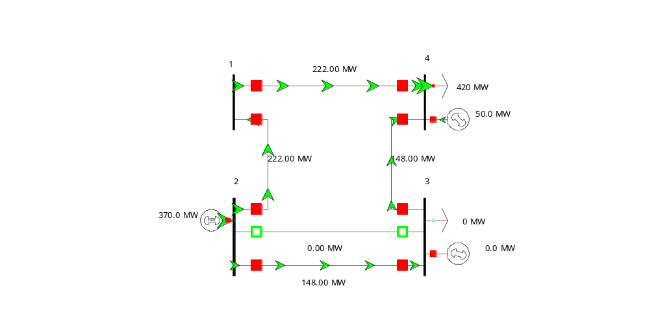
It is found that the sensitivity is 148/370 = 0.4
Therefore, Gen C has to increase its output by (372-350)/0.4 = 55 MW. Total production of Gen C is now 50 + 55 = 105 MW. The diagram below shows that the overloading problem of line 2-3 is now solved.
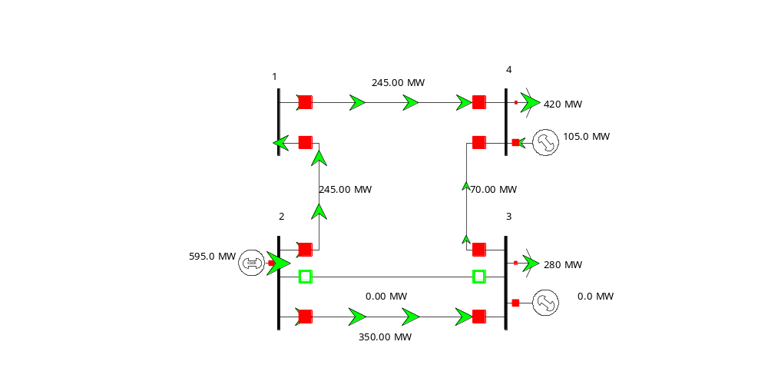 [4]

- The cost of generation is now : 595*25+105*60 = £21175/h. The cost of security is then: 21175 – 19250 = £1925/h
[2]
- In order to maximize the output of Gen A (lowest marginal cost), and considering the spare capacity at line 2-1 and 1-4, the Quadrature-booster should be installed at line 2-1 (or 1-4).
The QB is installed at line 1-4 with the phase-shifter position at -11.03°.
Bus 3: (calculation with MVA base =100 MVA)
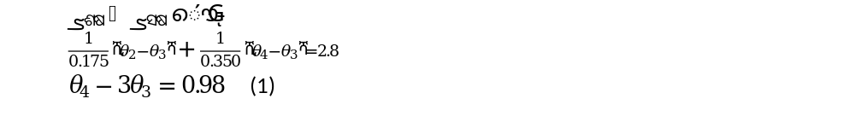
Bus 4: 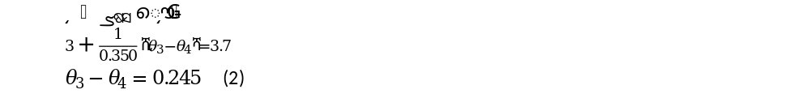

We know that flows at line 2-1-4 is equal 300 MW; therefore,
Therefore, the phaseshift position should be set at 0.1925 rad [5]

Solution Question 2

a. Provide definitions for CML and CI. What are typical CML and CI values for UK distribution networks?
[3]
CML/CI definitions [from RIIO-ED1 glossary of terms]:
Customer minutes lost (CML): Duration of interruptions to supply per year. This is the average customer minutes lost per customer per year, where an interruption of supply to customer(s) lasts for three minutes or longer.
Customer interruptions (CI): This is the number of customers whose supplies have been interrupted per 100 customers per year over all incidents, where an interruption of supply lasts for three minutes or longer, excluding re- interruptions to the supply of customers previously interrupted during the same incident.

Typical numbers for UK distribution network companies lie in the range 25-100 (CI) and 35-70 (CML).
Grading:
- 1 point for correct CML definition; 1 point for correct CI definition; this should include the 3 minute cut-off, and the 100 customer scaling for CI.
- 1 point for CML/CI estimates in the correct range. This should be an indicative number within the correct range or an overlapping range (sufficiently narrow to not include 9 or 201).

Consider a section of a distribution network that serves 3000 customers. The table below lists the outage events that occurred on this network in 2015.

Customers affected | Duration
200 | 3 hours
500 | 10 minutes
1500 | 2 minutes
100 | 2 hours
20 | 2 days
300 | 30 minutes
1000 | 1 hour

b. Compute the CML and CI values for this section of the network.
[3]

Due to the 3-minute minimum requirement for CML and CI, the recorded event that affected 1500 customers for 2 minutes will be excluded from CML/CI calculations.
Taking care to convert hours and days to minutes (for CML), the CML and CI are calculated as
$$\text{CML}\text{=}\frac{\sum_{events}{N_{affected}T_{minutes}}}{N_{customers}}=\frac{200×180 + 500×10 + 100×120 + 20×2×24×60 + 300×30 + 1000×60}{3000}=59.9\text{ minutes}$$
$$\text{CI}\text{=100}\text{×}\frac{\sum_{events}{N_{affected}}}{N_{customers}} \\ =100×\frac{200+500+100+20+300+1000}{3000} \\ =70.7$$
Grading:
- 1 point for correctly excluding the 2-minute event
- 1 point for getting the CML/CI formulas right
- 1 point for getting the correct numbers

Consider the following distribution network.
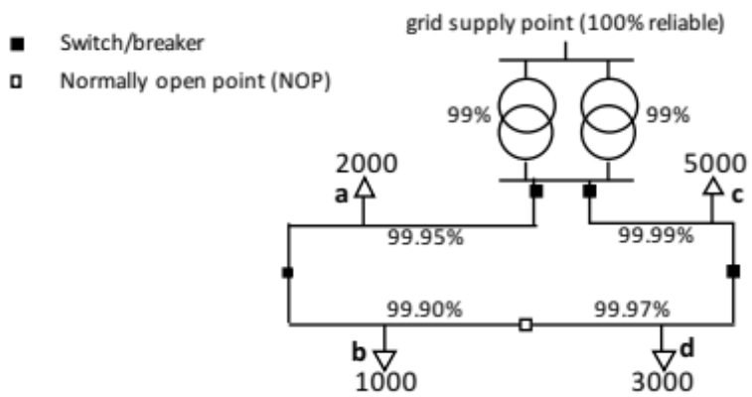
The load points (a-d) are labelled with the number of customers connected to each load point. The maximum diversified load is 1kW per customer, at 0.85 load factor. The capacity of each transformer is 15MVA. The availability of each component (transformer, feeder section) is listed alongside it as a percentage. Component failures are assumed to be independent and last more than 3 minutes each. The network is radially operated, but the normally open point (NOP) provides a degree of redundancy: the NOP is normally open, but it can be closed to resupply (b) or (d) in case of an upstream fault in the feeders at (a) or (c). You may assume that the normally open point reroutes power within 3 minutes.
The customers are a mixture of residential and SME customers, according to the table below. The customer interruption costs are £10,000/MWh for residential customers and £35,000/MWh for SMEs, and their average power consumption during outages is 0.4 kW (residential customer) and 2.5 kW (SME customer).

Load point | Residential customers | SME customers
a | 1900 | 100
b | 1000 | 0
c | 4700 | 300
d | 2700 | 300

c. Derive expressions for the probabilities that each of the the load points is connected to the grid supply point (one expression for each load point). Then compute the expected CML value for this network.
[7]
Notation: we use $\operatorname{Pr}\left(x\right)$ to denote the availability of component $x$.

There are 11,000 customers connected to the network. The maximum required transformer capacity is
$$11,000×\frac{1000\text{kW}}{0.85}=12.94\text{MVA}$$so the 15MVA transformers are fully redundant. We only need to compute the probability that at least one transformer is available:
$$\operatorname{Pr}\left(tr\right)=1-\left(1-0.99\right)×\left(1-0.99\right)=0.9999$$

Load points (a)and (c) can only be supplied through their directly attached feeders, and require one or more transformers to be operational, resulting in:
$$\operatorname{Pr}\left(a\right)=\operatorname{Pr}\left(tr\right)×\operatorname{Pr}\left(feeder_{a}\right)=0.9999×0.9995=0.9994 \\ \operatorname{Pr}\left(c\right)=\operatorname{Pr}\left(tr\right)×\operatorname{Pr}\left(feeder_{c}\right)=0.9999×0.9999=0.9998$$

Load points (b) and (d) have a redundant supply through the NOP. Power supply to load point (b) requires the local feeder section AND a transformer to be available, as well as EITHER the feeder section at (a) OR the feeder sections along (c) AND (d). This results in
$$\operatorname{Pr}\left(b\right)=\operatorname{Pr}\left(tr\right)×\operatorname{Pr}\left(feeder_{b}\right)×\left(1-\left(1-\operatorname{Pr}\left(feeder_{a}\right)\right)\left(1-\operatorname{Pr}\left(feeder_{c}\right)\operatorname{Pr}\left(feeder_{d}\right)\right)\right) \\ =0.9999×0.9990×\left(1-\left(1-0.9995\right)\left(1-0.9999*0.9997\right)\right)=0.9989$$
Similarly, load point (d) requires
$$\operatorname{Pr}\left(d\right)=\operatorname{Pr}\left(tr\right)×\operatorname{Pr}\left(feeder_{d}\right)×\left(1-\left(1-\operatorname{Pr}\left(feeder_{c}\right)\right)\left(1-\operatorname{Pr}\left(feeder_{a}\right)\operatorname{Pr}\left(feeder_{b}\right)\right)\right) \\ =0.9999×0.9997×\left(1-\left(1-0.9999\right)\left(1-0.9995*0.9990\right)\right)=0.9996$$
The CML is computed as
$$\text{CML}=8760h×60min/h×\frac{\sum_{loadpoints}{N_{customers at loadpoint}×\text{unavailabilit}{\text{y}}_{\text{loadpoint}}}}{N_{customers}} \\ =8760h×60min/h×\frac{2000\left(1-\operatorname{Pr}\left(a\right)\right)+1000\left(1-\operatorname{Pr}\left(b\right)\right)+5000\left(1-\operatorname{Pr}\left(c\right)\right)+3000\left(1-\operatorname{Pr}\left(d\right)\right)}{11000} \\ =8760h×60min/h×\frac{2000×0.0006+1000×0.0011+5000×0.0002+3000×0.0004}{11000} \\ =215 \text{minutes}$$

Note that this uses the fact that all events last more than 3 minutes – so all events count towards the CML calculation.

Grading:
- 1 point for identifying the redundancy of the transformers
- 1 point for correctly computing the combined availability of the transformer pair
- 1 point for correctly computing the availability of load points (a) and (c)
- 2 points for correctly computing the availability of load points (b) and (d), taking into account the backup supply through the NOP.
- 2 points for correctly computing the CML (insofar as possible on the basis of previous answers).

d. Compute the expected annual cost of interruptions under these assumptions, using the load point supply probabilities in computed in (c).
[4]
Notation: we use $\operatorname{Pr}\left(x\right)$ to denote the availability of component $x$.

The average customer interruption costs for a residential customer at load point $x$ is given by
$$E\left[cost_{res,x}\right]=\left(1-\operatorname{Pr}\left(x\right)\right)×0.4kW×8760h×\frac{£10,000/MWh}{1000kWh/MWh}=\left(1-\operatorname{Pr}\left(x\right)\right)×£35,040$$

For SME customers:
$$E\left[cost_{SME,x}\right]=\left(1-\operatorname{Pr}\left(x\right)\right)×2.5kW×8760h×\frac{£35,000/MWh}{1000kWh/MWh}=\left(1-\operatorname{Pr}\left(x\right)\right)×£766,500$$
The total expected cost for the residential and SME sectors, across all load points, is given by
$$E\left[cost_{res}\right]=£35,040×\left(1900\left(1-\operatorname{Pr}\left(a\right)\right)+1000\left(1-\operatorname{Pr}\left(b\right)\right)+4700\left(1-\operatorname{Pr}\left(c\right)\right)+2700\left(1-\operatorname{Pr}\left(d\right)\right)\right) \\ =£35,040×\left(1900×0.0006+1000×0.0011+4700×0.0002+2700×0.0004\right) \\ =£149,270$$

$$E\left[cost_{SME}\right]=£766,500×\left(100\left(1-\operatorname{Pr}\left(a\right)\right)+300\left(1-\operatorname{Pr}\left(c\right)\right)+300\left(1-\operatorname{Pr}\left(d\right)\right)\right) \\ =£766,500×\left(100×0.0006+300×0.0002+300×0.0004\right) \\ =£183,960$$

The total expected costs are therefore
$$E\left[cost\right]=E\left[cost_{res}\right]+E\left[cost_{SME}\right]=£333,230$$

Grading:
- 2 points for computing the correct relation between load point availability and residential/SME costs
- 2 points for correctly computing the total expected interruption costs for each sector.

e. Explain the Willingness-to-Pay and Willingness-to-Accept approaches to evaluating customer interruption costs. Do you expect similar values when using WTA and WTP? Which approach do you think is more suitable as a basis for interruption costs models? Motivate your answers.
[3]
“Willingness to Pay” (WTP): Ask respondents how much they would be willing to pay to avoid a given interruption scenario.
“Willingness to Accept” (WTA): Ask respondents the level of payment they would require to accept an interruption scenario.

To a rational decision maker (homo economicus), WTA and WTP would be identical, assuming the costs are not a significant part of the available budget. However, for human subjects WTA is usually much larger than WTP, due to the endowment effect. This is due to the asymmetric valuation of gains and losses.

Any consistently argued preference for WTA or WTP, or discussion about their relative strengths/weaknesses is acceptable.

Grading:
- 1 point for the correct definitions of WTA/WTP
- 1 point for stating that WTA (usually) exceeds WTP, and referring to the asymmetry in gaining or losing.
- 1 point for a consistent argument for any consistently argued preference for WTA or WTP, or discussion about their relative strengths/weaknesses.

Solution Question 3
Grading: a maximum of 20 points can be obtained. A maximum of two bonus points can be awarded (to offset minor mistakes) for particularly ingenious solutions or arguments.

a. The reliability of a 5km underground cable is modelled as a repairable two-state system. Its failure rate is 0.023/km/year and its availability is 0.9998. What is the mean time to repair?
[3]
The total failure rate of the cable is
$$5km×\frac{0.023}{km year}=\frac{0.115}{year}=\frac{1}{MTTF}$$so that $MTTF=8.70$ years.
Availability (0.9998) relates to MTTF and MTTR as
$$av=\frac{MTTF}{MTBF}=\frac{MTTF}{MTTF+MTTR}$$Solving for MTTR gives
$$MTTR=\frac{MTTF}{av}-MTTF \\ =MTTF\left(\frac{1}{av}-1\right) \\ =8.70year×8760\frac{hours}{year}×\left(\frac{1}{0.9998}-1\right) \\ =15.25 hours$$
Grading:
- 2 points for determining the relation between MTTR, availability and MTTF (using failure rate and length)
- 1 point for correctly computing the MTTR

Consider an automated monitoring and control system that has two failure modes: (1) a ‘soft’ failure that is automatically detected and rectified by reinitialising the system; (2) a ‘hard’ failure that requires a field visit by an engineer. We will model this process as a Markov chain with 3 states and the following transition rates: soft failure rate: 1in 20 days; hard failure rate: 1 in 230 days; recovery rate from soft failure: 0.5 per hour; hard failure repair rate: 0.5 per day.

b. Draw the corresponding continuous-time Markov chain model, using consistent units (hours or days) for all transition rates.
[2]
The following diagram represents all transitions in units of inverse days. Inverse hours is acceptable, too.

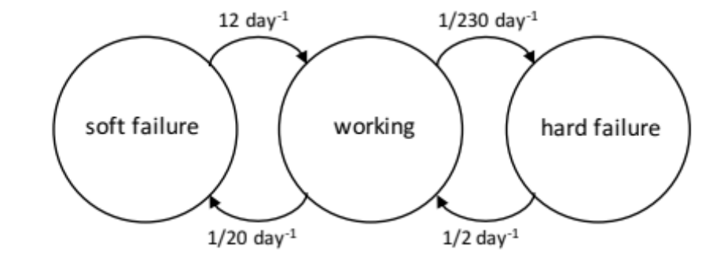

Grading:
- 1 point for drawing the states with the correct connectivity (including directions)
- 1 point for assigning the correct numerical value to the transition rates (in consistent units).

c. Derive a discrete time Markov chain for this process, assuming a time step of 1 hour. Draw it, including all non-zero transition probabilities. Do you think that the discrete time Markov chain with a time step of 1 hour is a good approximation of the continuous time process? Motivate your answer.
[3]
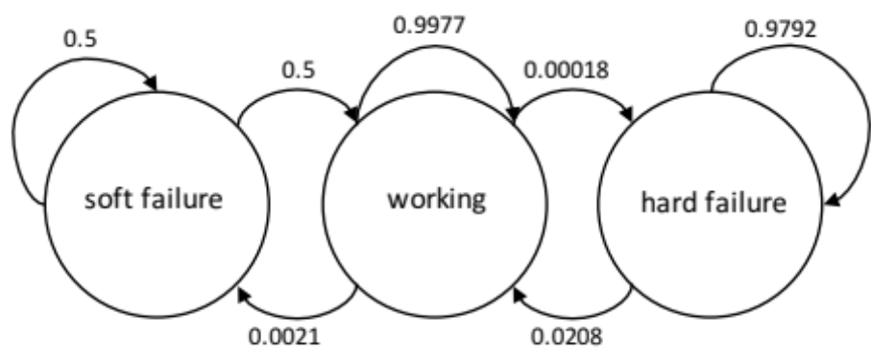
It is doubtful whether the discrete time Markov chain is sufficiently accurate as an approximation for the continuous time version. The biggest issue is that the soft failure repair process is (in the continuous version) an exponential distribution with a mean of 2 hours. Discretisation into 1-hour time steps results in a very crude approximation. Whether this is a problem will depend on the application.

Grading:
- 1 point for identifying the need to include self-loops with a transition probability of 1 minus [outgoing probabilities]
- 1 point for computing the correct transition probabilities using an hourly time step.
- 1 point for pointing out potential issues due to the size of the time step, referring to the ‘soft failure’ mode in particular.

Consider a demand aggregator that controls the load of a portfolio of customers (large electricity consumers). It uses this controllability to offer a load shedding service to National Grid. When activated, an incoming load shedding signal from the National Grid control room is processed by two redundant computer systems. The computers then select appropriate loads to shed and send the necessary instructions over separate communication links. There is one communication link per customer, but this link is shared between both computer systems. Assume that the load shedding signal is sent to two customers.

To model the reliability of this system we will assume that the National Grid load shedding signal is 100% dependable. All other components (computer system, communications links, load shedding equipment at customer premises) are modelled as repairable systems. Failures are assumed to be independent.

d. Draw a reliability block diagram for the successful load shedding of both customers.
[2]

There are six components to be included. The computer systems are fully redundant, and are therefore modelled as parallel components in the RBD. Both loads must be disconnected, so they (and their communication links) are placed in series.
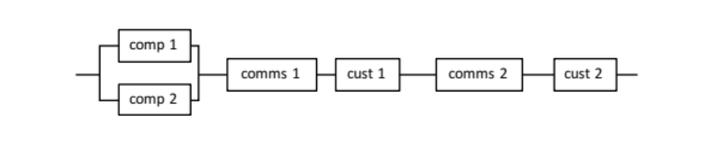
Grading:
- 1 point for identifying the correct components to include in the diagram
- 1 point for constructing the correct diagram (computers parallel; rest in series)

e. Draw a reliability block diagram for the successful load shedding of at least one of the two customers.
[2]

The action is successful if either load is disconnected, resulting in redundancy. However, successfully disconnecting a load requires both the communications link and the customer action to operate correctly – hence those should be in series.
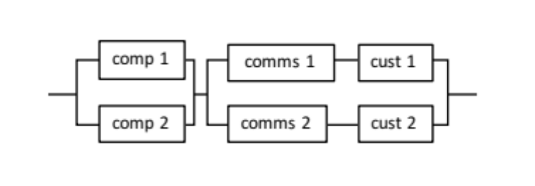
Grading:
- 1 point for identifying the need to create a second parallel section in the diagram
- 1 point for constructing the correct diagram.

f. Assuming an availability of 98% for each component, quantify the probability of success for each of the diagrams in (d) and (e).
[2]
With 98% availability for each component the probability of success for the system in (d) is:
$$\operatorname{Pr}\left(system_{d}\right)=\left(1-\left(1-0.98\right)\left(1-0.98\right)\right)×{0.98}^{4}=0.922$$
The probability of success for the system in (e) is:
$$\operatorname{Pr}\left(system_{e}\right)=\left(1-\left(1-0.98\right)\left(1-0.98\right)\right)×\left(1-\left(1-0.98×0.98\right)\left(1-0.98×0.98\right)\right)=0.998$$
Clearly, the probability of success is much larger for system (e), where only a single successful load shedding action is required (but two are attempted). The failure rate is 39 times smaller.

Grading:
- 1 point for identifying the correct equations from the diagrams in (d) and (e).
- 1 point for computing the correct success probabilities.

Monte Carlo methods

g. What is the formula for the Monte Carlo estimator for the risk $R=E[X]$, using $N$ samples of the random variable $X$?
[2]
The Monte Carlo estimator for $R=E\left[X\right]$ is
$$\hat{R}=\frac{1}{N}\sum_{i=1}{x_{i}}$$where $N$ is the number of samples and $x_{i}$ are the sample values.
Grading:
- 1 point for giving the equation for the sample average
- 1 point for clearly indicating that the quantities being averaged are sample values $x_{i}$ (and thus specific values, not random variables $X$).

A snapshot Monte Carlo simulation is used to estimate the expected cost of interruptions. After N=10,000 samples the best estimate of the cost is £108,762, with a standard error of £2581.
h. How many samples will be required (approximately, in total) to reduce the standard error of the mean to £1000?
[2]
The standard error after 10,000 samples is £2581. The standard error scales as
$$se=\frac{σ_{X}}{\sqrt{N}}$$so to solve for $se^{'}=£1000$ we need to solve
$$N^{'}={\left(\frac{σ_{X}}{se'}\right)}^{2}={\left(\frac{se\sqrt{N}}{se'}\right)}^{2}={\left(\frac{£2581}{£1000}\right)}^{2}N=66,616$$
Grading:
- 1 point for stating the correct scaling with $N$ (inclusion of $σ_{I}$ is not compulsory)
- 1 point for computing the (approximate) number of samples required using the ratio of squared standard errors.

i. How many samples will be required (approximately, in total) to reduce the width of the 95% confidence interval for the mean to £1000?
[2]
To reduce the 95% confidence interval to £1000, we require that both tails of the interval (1.96 standard errors each) fit within the range. This requires a standard error se’ that satisfies
$$2×1.96×se'=£1000$$so that
$$se'=£255$$
Using the same formula as used in (h), the required number of samples becomes
$$N'={\left(\frac{£2581}{£255}\right)}^{2}N=1,024,462$$

Grading:
- 1 point for identifying the correct relation between the standard error and the 95% confidence interval
- 1 point for correctly computing the (approximate) required number of samples in the vicinity of 1 million.

Solution Question 4

Part I: Flexible Demand
a) Under centralised scheduling, the smart control systems of flexible demand appliances need to communicate their technical and economic characteristics to a central system entity which makes decisions on the scheduling of the appliances based on the solution of a global optimisation problem and communicates according dispatch signals to the appliances. Under a significant penetration of flexible demand appliances however, the communication and computational scalability of centralised mechanisms is at least questionable in both technical and economic terms. Transmission of the complex and diverse operational constraints and physical parameters of a very large number of demand appliances to the central entity will yield information collection and communication problems, while the vast number of decision variables and constraints associated with these appliances will create a massive computational burden to the central entity. Furthermore, centralised scheduling is likely to raise privacy concerns by the consumers, as they are not generally willing to disclose sensitive information (such as habits, preferences and appliances’ properties) and be directly controlled by an external entity.
Under price-based scheduling, these scalability and privacy limitations are avoided. Without communicating their individual characteristics to the central entity, flexible demand appliances are exposed to time-differentiated prices and self-schedule their demand to minimise the electricity cost incurred by their operation. More specifically, the posted prices are higher during peak demand periods and lower during off-peak demand periods to incentivise appliances to redistribute their energy requirements towards the latter and therefore improve the efficiency of system operation. However, naive application of dynamic pricing in combination with the envisaged automation in appliances’ control leads to serious loss of diversity and demand response concentration phenomena. Specifically, appliances’ demand is concentrated at the periods with the lowest prices, yielding significant new demand peaks and thus inefficient system operation. [4]

b)
i) Total generation must be equal to total demand at each hour
$s_{1}=D_{1}+1000*d_{1}$ and $s_{2}=D_{2}+1000*d_{2}$
Due to the quadratic form of the generator’s cost function
The total generation costs are minimised when $\left|s_{1}-s_{2}\right|$ is minimised
Combining the above equations means that the objective is
Minimise $\left|\left(D_{1}+{1000*d}_{1}\right)-(D_{2}+{1000*d}_{2})\right|$
While the operating constraints of the generator and the flexible demand appliances are satisfied
Generator: $D_{1}+{1000*d}_{1}≤s^{max}$ and $D_{2}+{1000*d}_{2}≤s^{max}$
Flexible demand appliances: $d_{1}≤d^{max}$, $d_{2}≤d^{max}$and $d_{1}+d_{2}=E$
This is achieved when $d_{1}=2$ kW and $d_{2}=3$ kW
The total generation cost is $50{(D_{1}+{1000*d}_{1})}^{2}+50{(D_{2}+{1000*d}_{2})}^{2}=£2500$
[2.5]

ii) The price at hour 2 should be lower ($λ_{1}$ > $λ_{2}$) in order to incentivise flexible demand appliances to move their demand to the off peak-hour 2 and flatten the system demand profile.
Each flexible demand appliance aims at minimising its electricity cost. Therefore, it will obtain as much energy as possible at the hour with the lowest price and the rest at the hour with the highest price:
$d_{2}=d^{max}=5$kW and $d_{1}=E-d_{1}=0$kW
Central entity schedules the generator to meet resulting demand:
$s_{1}=D_{1}+1000*d_{1}=3$MW and $s_{2}=D_{2}+1000*d_{2}=7$MW
The total generation cost is $50{(D_{1}+{1000*d}_{1})}^{2}+50{(D_{2}+{1000*d}_{2})}^{2}=£2900$
The total generation costs are significantly higher than the costs under centralised scheduling. This happens because of the concentration of flexible demand response at the hour with the lowest price.
[3.5]

Part II: Big Data

a)The primary sources of big data in power systems are:
− Phasor Measurement Units (PMUs)
− Asset monitoring data from various system assets e.g. transformers
− Smart meters
− Electricity market data [2]
b)
Any three of these techniques:
- Statistical modelling techniques/data-driven modelling
- Machine learning techniques
- Large-scale data storage
- Massive task parallelisation/High Performance Computing (HPC)
- Data visualisation [2]
c)
- Regarding asset health monitoring:
Traditionally, asset maintenance has been scheduled on empirical rules (e.g. replace an asset every 10 years) and has been largely reactive (i.e. replace after a fault occurs). Big data analytics enable the real-time health monitoring of assets to improve efficiency. An example can be given for the case of monitoring of wind turbines to identify when maintenance should be carried out. By recording high-frequency observations of wind-speed and power output, a statistical model can be built to characterise the ‘basecase’ transfer function of a healthy asset. New observations can be compared against the basecase model and a ‘distance metric’ can be computed; divergence between measurements and model indicate need for maintenance. [2]
- Regarding the characterisation of residential electricity consumption:
Traditional energy meters were read once a month. Smart metering data (and meta-data records in terms of household size and appliances) Validity indicator analysis and data clustering techniques can be used for customer classification in order to design suitable Time-of-Use tariffs and identify suitable profiles for demand-side response schemes. [2]
- Regarding situational awareness:
Traditionally, security assessment has been carried out at a limited, ad-hoc basis, largely based on empirical rules. Big data analytics can be applied to data gathered from phasor measurement units (PMUs) to carry out large-scale security assessment and improve situational awareness. In particular, historical PMU data contain information on what operating points the operator should anticipate in the future. Simulations of faults can be carried out to identify whether each anticipated operating point is stable or unstable. Machine learning techniques are then used to produce security rules describing the system’s security boundary. [2]

